Child Mandala App

A Mobile Platform for Child Protection & Parenting Support in Bhutan

Proposal for UNICEF BHUTAN

2025

# 1. The Challenge

## Why This Matters Now

Bhutan, while making significant strides in development, faces emerging challenges that threaten the well-being of its children. As the nation modernizes, families encounter new pressures that require innovative solutions to ensure every child grows up safe, healthy, and protected.

**Rising Social Challenges Facing Bhutanese Children:**

* **Mental Health Concerns:** Increasing rates of anxiety, depression, and stress among youth, exacerbated by academic pressures and changing social dynamics. Studies indicate that adolescent mental health issues have risen significantly in recent years.
* **Digital Exposure Risks:** With smartphone penetration at 85%, children are increasingly exposed to online content without adequate supervision or digital literacy. Screen time among children has increased dramatically, raising concerns about content exposure and online safety.
* **Nutrition Deficiencies:** Despite improvements, malnutrition and micronutrient deficiencies persist, particularly in rural areas. Parents often lack access to reliable nutritional guidance appropriate for different developmental stages.
* **Violence Against Children:** Cases of physical, emotional, and sexual abuse continue to be reported. Many incidents go unreported due to lack of awareness about reporting mechanisms and fear of social stigma.
* **Online Safety Threats:** Cyberbullying, exposure to inappropriate content, online grooming, and privacy violations are growing concerns as children spend more time online without adequate protection measures.

**Gaps in Parenting Support:**

* **Limited Access to Guidance:** Evidence-based parenting resources are scarce and often inaccessible to most families. Existing materials are frequently in English only and may not reflect Bhutanese cultural contexts.
* **Rural Underservice:** Families in remote areas have minimal access to parenting workshops, counseling services, or child development specialists. Geographic isolation creates significant barriers to support.
* **Cultural Appropriateness:** Available parenting content is often developed for Western contexts and fails to address the unique cultural, social, and religious aspects of Bhutanese family life.
* **Language Barriers:** Many parents, especially in rural areas, are more comfortable with Dzongkha. The lack of localized content in the national language limits reach and effectiveness.

**The Opportunity:**

Bhutan presents a unique opportunity to leverage technology for child protection at scale:

* **85% mobile penetration** - The majority of Bhutanese families now have access to smartphones, creating an unprecedented channel for reaching parents with critical information.
* **Growing digital literacy** - Younger parents are increasingly comfortable with mobile applications and digital content consumption.
* **Government support** - The Royal Government of Bhutan prioritizes child welfare and digital transformation, creating a favorable environment for technology-based solutions.
* **UNICEF presence** - Strong institutional support and expertise in child protection provides a foundation for evidence-based content and sustainable implementation.

# 2. Our Vision

## Building a Protection Ecosystem Through Technology

**Mission Statement:** To leverage mobile technology to deliver child protection awareness and age-appropriate parenting content to every family in Bhutan, creating a comprehensive ecosystem that supports children's well-being from prenatal stages through adolescence.

Our vision extends beyond a simple mobile application. We aim to create a holistic digital ecosystem that connects parents, children, communities, and government agencies in a unified effort to protect Bhutan's children. This platform will serve as the primary digital touchpoint for child protection and parenting support nationwide.

**Core Pillars of Our Approach:**

1. **Prevention:** Proactive education before issues arise. By providing parents with knowledge about child development stages, potential risks, and protective factors, we can prevent problems before they occur. This includes early warning signs recognition, positive discipline techniques, and age-appropriate safety education for children.
2. **Awareness:** Evidence-based guidance delivered at scale. All content is developed in collaboration with child development experts, psychologists, and UNICEF specialists. The ICAP (Integrated Child and Adolescent Parenting) framework ensures that guidance is scientifically sound and culturally adapted for Bhutanese families.
3. **Access:** Universal availability regardless of location or economic status. The app is designed to work on basic smartphones with limited data connectivity. Content is available offline after initial download, ensuring rural families can access information even with intermittent internet. Dzongkha language support ensures no family is left behind due to language barriers.
4. **Convergence:** Uniting health, education, protection, and security sectors in one platform. The app serves as a convergence point where multiple government agencies and NGOs can share resources, coordinate events, and provide integrated services to families. This multi-sectoral approach ensures comprehensive support.

## Expected Outcomes

* **Increased Awareness:** Parents across Bhutan will have access to consistent, quality information about child protection and development.
* **Earlier Intervention:** Easy reporting mechanisms will enable faster response to child protection concerns.
* **Stronger Communities:** Events and community features will foster local support networks for families.
* **Data-Driven Policy:** Analytics from the platform will provide insights for evidence-based policy decisions.

# 3. Target Users

## Who We Serve

The Child Mandala App is designed to serve multiple user groups, each with distinct needs and interaction patterns. The application provides tailored experiences for each user type while maintaining a unified platform.

|  |  |  |
| --- | --- | --- |
| **User Type** | **Need** | **Solution** |
| Expecting Parents | Prenatal care guidance | Pregnancy chapter with health tips |
| Parents of 0-17 | Age-specific parenting support | Content that adapts as children grow |
| Children | Safe learning environment | Child-friendly mode with age-appropriate content |
| Community Workers | Tools for outreach | Events, resources, reporting |

### Detailed User Profiles

**Expecting Parents:**

First-time and experienced parents expecting a child need guidance on prenatal care, nutrition during pregnancy, preparing for childbirth, and understanding what to expect in the early months. The app provides the Pregnancy chapter with comprehensive information on each trimester, warning signs to watch for, and preparation checklists.

**Parents of Children 0-17:**

The primary user group includes parents and caregivers of children from birth through adolescence. These users need age-specific guidance that evolves as their children grow. The app's smart filtering ensures they see relevant content - a parent of a toddler sees different chapters than a parent of a teenager. Topics cover physical development, emotional well-being, education support, discipline approaches, and safety awareness.

**Children (Supervised Access):**

Children themselves can use the app in a supervised, age-appropriate mode. The child-friendly interface presents safety information, educational content, and interactive features in an engaging way. The PIN-protected child login ensures children only access content appropriate for their age group, with colorful visuals and simplified navigation designed for younger users.

**Community Workers & Educators:**

Health workers, teachers, social workers, and community volunteers can use the app as a resource during their outreach activities. The events feature allows agencies to publish workshops and training sessions, while the reporting mechanism provides a channel for professionals to report concerns they encounter in their work.

**Reach Potential:** With 85% mobile penetration and a population of approximately 780,000, the app can potentially reach over 150,000 households with children across all 20 dzongkhags of Bhutan.

# 4. The Solution: Child Mandala App

The Child Mandala App represents a comprehensive digital solution that builds upon existing infrastructure while introducing transformative new capabilities. The development approach prioritizes both continuity with existing systems and innovation to address emerging needs.

## Existing Features (Enhanced)

The following features were already present in the previous system and have been enhanced and integrated into the new platform:

* **Interactive Mandala:** The signature visual interface featuring a clickable mandala design that serves as the primary navigation hub. Users can tap different sections of the mandala to access various features. This culturally significant design element has been retained and optimized for better performance and accessibility.
* **News Portal:** A news and updates section that delivers the latest information from UNICEF, partner agencies, and relevant government announcements. The news portal has been enhanced with better categorization, search functionality, and the ability to save articles for offline reading.

## New Add-ons

The following features represent completely new additions to the platform, significantly expanding its capabilities:

* **Dual-User System:** A sophisticated architecture that provides separate interfaces for parents and children. Parent Mode offers full access to all content, child management, reporting tools, and settings. Child Mode presents a simplified, colorful interface with age-filtered content and engaging visuals. Each mode is optimized for its intended user.
* **Phone + OTP Authentication:** Secure authentication using mobile phone numbers and one-time passwords sent via SMS. This approach eliminates the need for complex passwords while ensuring account security. Users can easily recover access using their registered phone number.
* **PIN-based Child Login:** A child-friendly authentication system using 4-digit PINs. Each child profile has a unique PIN, allowing children to log in independently while ensuring they only access their own age-appropriate content. The PIN system is designed for simplicity while maintaining security.
* **ICAP Parenting Content:** Eight comprehensive chapters based on the Integrated Child and Adolescent Parenting framework. Each chapter includes video introductions (via YouTube), expandable topic sections, and easy-to-read content formatted in markdown. Content is developed in collaboration with child development experts.
* **Age-Based Content Filtering:** An intelligent system that calculates each child's age group based on their date of birth and automatically filters content accordingly. Children see only chapters relevant to their developmental stage, ensuring age-appropriate information delivery.
* **Online Safety Education:** A dedicated section based on the 4 C's Framework (Content, Conduct, Contact, Contract) aligned with Bhutan's Cybersecurity Framework. Provides parents and children with practical guidance on staying safe online, recognizing risks, and responding to incidents.
* **Community Events:** A comprehensive events section where agencies can publish upcoming workshops, seminars, and training sessions. Users can browse events by category (seminars, workshops, training) or audience (parents, children, educators), view details, and access registration links.
* **Incident Reporting:** An easy-to-use reporting mechanism for users to report child protection concerns directly through the app. Reports are channeled to appropriate agencies with tracking capabilities. This lowers barriers to reporting and enables faster response times.
* **Bilingual Support:** Full support for English and Dzongkha languages throughout the application. Users select their preferred language on first launch and can switch anytime. All UI strings, content, and navigation elements are available in both languages.

## MAJOR ENHANCEMENT: AI Chatbot Integration

The AI Chatbot represents a transformative technological advancement that positions the Child Mandala App at the forefront of digital child protection solutions. This feature addresses a critical gap: the need for immediate, accessible guidance when parents have questions or concerns.

**Current Prototype Capabilities:**

* **Instant Responses:** Users can ask questions about parenting, child development, safety concerns, and app features, receiving immediate helpful responses.
* **Child Protection Information:** The chatbot is trained to provide accurate information about child rights, protection laws, and appropriate responses to various situations.
* **Emergency Direction:** When users describe urgent situations, the chatbot immediately provides emergency contact numbers (Police: 113, Child Helpline: 1098) and guides them to appropriate resources.
* **Friendly Interface:** A conversational chat interface with typing indicators makes interactions feel natural and approachable, reducing barriers to seeking help.

**Future AI Potential:**

* **LLM-Powered Responses:** Integration with large language models will enable more nuanced, contextual responses to complex parenting questions.
* **Voice Support:** Voice input and output capabilities will make the chatbot accessible to users with limited literacy, dramatically expanding reach.
* **Multi-Lingual AI:** Future versions will support conversational AI in both English and Dzongkha, with potential for additional local languages.
* **Personalized Guidance:** AI that learns from user interactions to provide increasingly personalized and relevant parenting advice.

**Why This Matters:** The AI chatbot is a game-changer because it provides scalable, 24/7 support without the human resource constraints that limit traditional helplines. A parent in a remote village can get guidance at 2 AM just as easily as a parent in Thimphu during business hours.

# 5. App Features - Detailed Overview

This section provides a detailed walkthrough of each major feature in the Child Mandala App, with accompanying screenshots demonstrating the user interface and functionality.

## 5.1 Home Screen & Navigation

The home screen serves as the central hub of the application, featuring the signature interactive mandala design that pays homage to Bhutanese cultural heritage while providing intuitive navigation.

**Key Features:**

* **Interactive Mandala:** Each segment of the mandala is tappable, leading to different sections of the app. The design is visually engaging while maintaining functional clarity.
* **Quick Access Menu:** Bottom navigation provides rapid access to frequently used features including Home, Learning, Events, Safety, and Profile.
* **Personalized Greeting:** The home screen displays a personalized welcome message and can show notifications about new content or upcoming events.

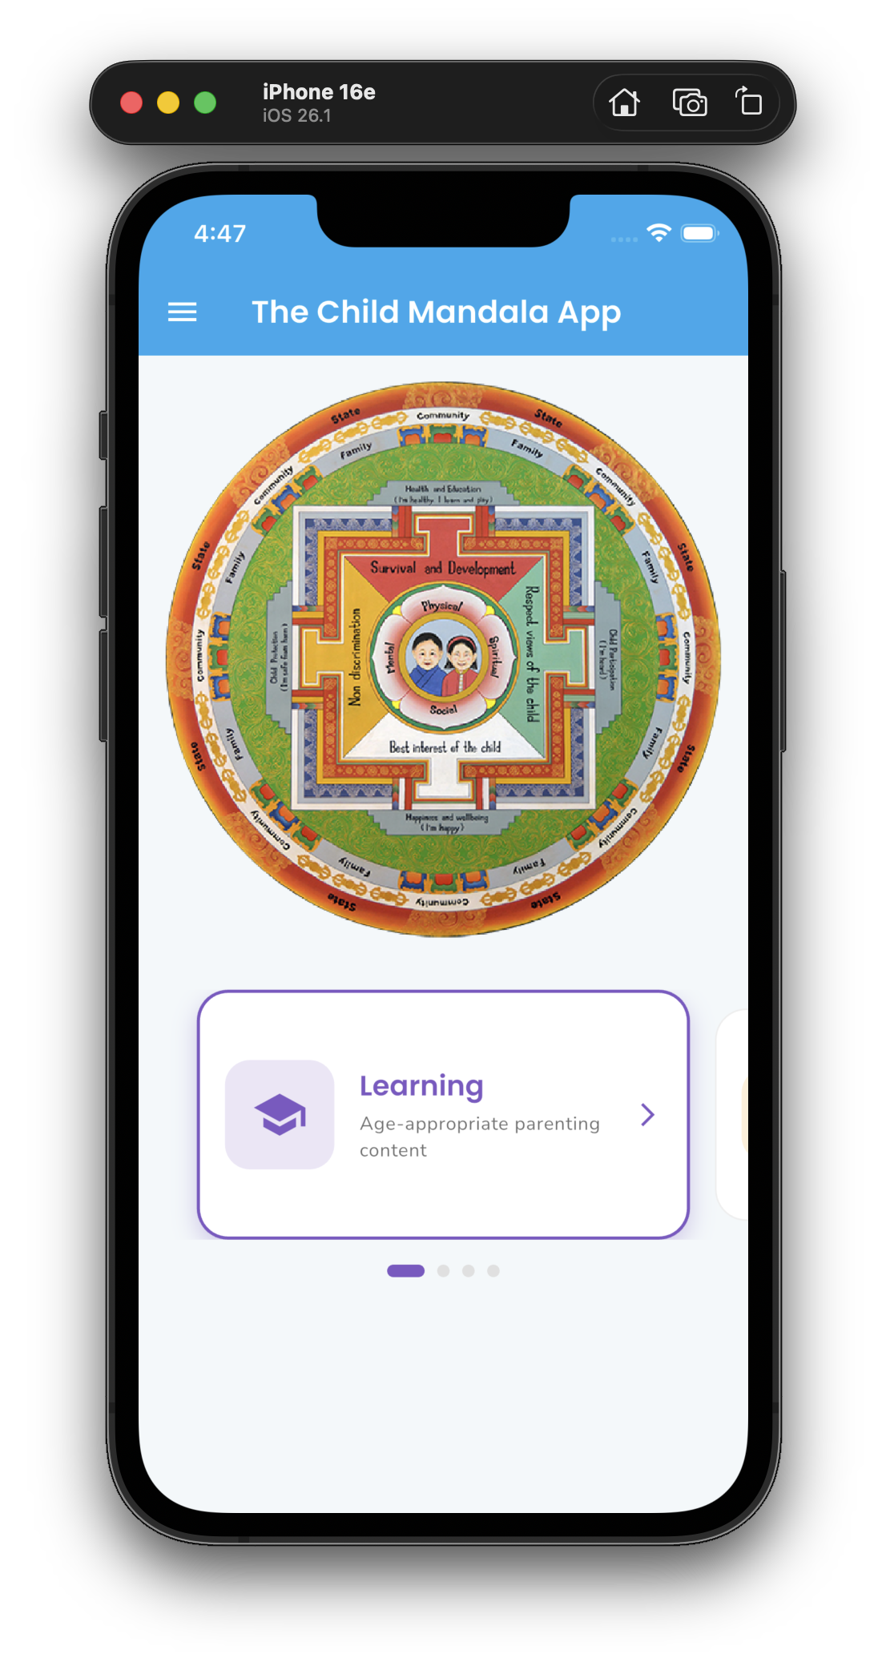

*Home Screen with Interactive Mandala*

## 5.2 ICAP Content Framework

The ICAP (Integrated Child and Adolescent Parenting) content framework forms the educational backbone of the application. Developed with child development experts and aligned with UNICEF guidelines, this content provides comprehensive, evidence-based parenting guidance.

**The 8 Comprehensive Chapters:**

1. **Child Development Overview (All ages):** Foundation knowledge about developmental milestones, understanding child behavior, and creating supportive environments.
2. **Pregnancy & Prenatal Care:** Guidance for expecting parents covering nutrition, health checkups, preparing for birth, and emotional well-being during pregnancy.
3. **Birth to 3 Years:** Critical early years content including feeding, sleep, immunizations, early stimulation, bonding, and identifying developmental delays.
4. **Preschool (3-5 Years):** Preparing for formal education, social skill development, play-based learning, and managing behavioral challenges.
5. **Primary School (6-12 Years):** Supporting academic success, building friendships, handling peer pressure, and introducing age-appropriate responsibilities.
6. **Adolescent/Teen (13-17 Years):** Navigating puberty, mental health awareness, online safety, substance abuse prevention, and preparing for adulthood.
7. **Cross-Cutting Issues:** Topics relevant across all ages including positive discipline, communication skills, child protection, and special needs awareness.
8. **Self-Care for Parents/Caregivers:** Recognizing caregiver stress, self-care strategies, seeking support, and maintaining healthy family relationships.

**Content Format:**

* Each chapter opens with an introductory YouTube video providing an engaging overview
* Topics within each chapter are expandable/collapsible for easy navigation
* Content is written in accessible language, avoiding medical jargon
* Key points are highlighted with visual formatting for quick reference

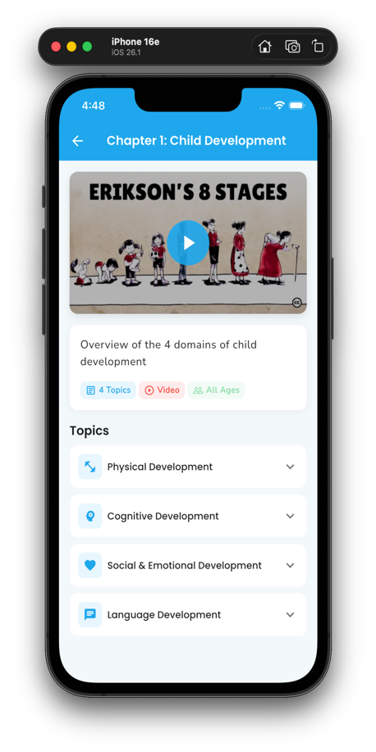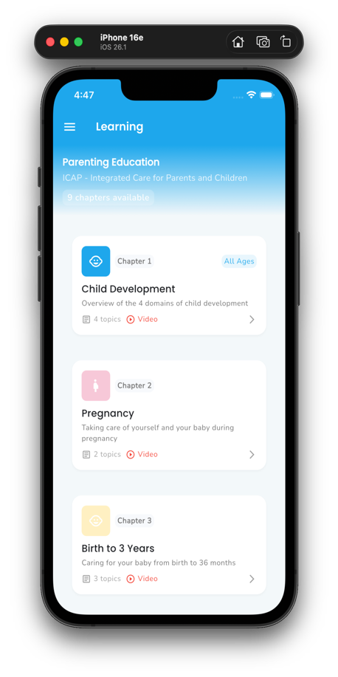

*Parent Learning Screen showing Chapter List Chapter Content View with Expandable Topics*

## 5.3 Age-Based Content Filtering

One of the app's most innovative features is its intelligent content filtering system. This ensures that both parents and children see content that is specifically relevant to the child's current developmental stage.

**How It Works:**

1. **Profile Creation:** Parents create a profile for each child, entering their date of birth and basic information.
2. **Automatic Calculation:** The system automatically calculates the child's age group based on their DOB and updates as they grow.
3. **Filtered Display:** When the child logs in, they only see content appropriate for their age group - no manual filtering required.

**Age Group Mapping:**

|  |  |  |
| --- | --- | --- |
| **Stage** | **Ages** | **Chapters Visible** |
| Pregnancy | Expected | Overview, Pregnancy, Self-care |
| Infant | 0-3 years | Overview, Birth-3, Self-care |
| Toddler | 3-5 years | Overview, Preschool, Self-care |
| Child | 6-12 years | Overview, Primary, Self-care |
| Teen | 13-17 years | Overview, Adolescent, Self-care |

**Note:** Parents always see all chapters to enable them to prepare for upcoming developmental stages and understand the full scope of available content.

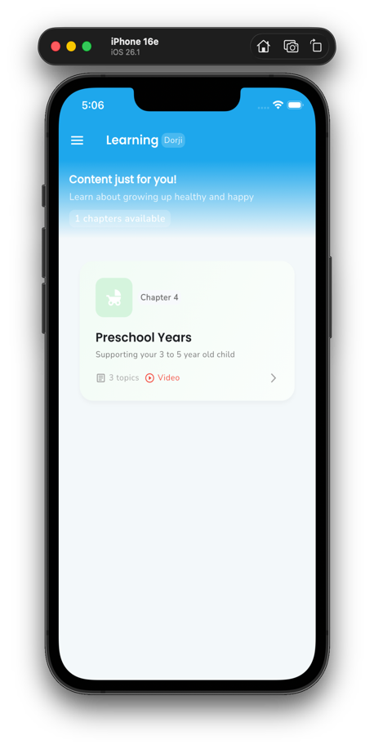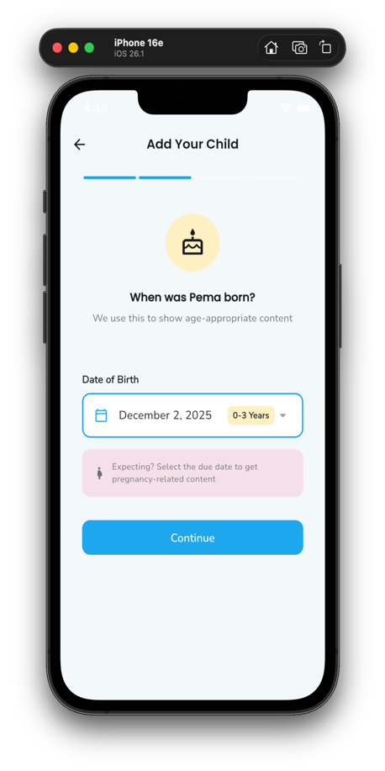

*Adding Child Profile with Date of Birth* *Age-Filtered Learning Content for Child*

## 5.4 Online Safety (4 C's Framework)

As Bhutanese children spend more time online, digital safety has become a critical concern. The Online Safety section provides comprehensive education for both parents and children, based on the internationally recognized 4 C's Framework and aligned with Bhutan's Cybersecurity Framework.

**The 4 C's Framework:**

|  |  |  |
| --- | --- | --- |
| **Category** | **Risk** | **App Feature** |
| **Content** | Harmful material, age-inappropriate | Safety tips, parental guidance |
| **Conduct** | Cyberbullying, online threats | Reporting mechanism, emergency contacts |
| **Contact** | Stranger danger, grooming | Education for children & parents |
| **Contract** | Privacy violations, scams | Data protection awareness |

**Section Features:**

* **Interactive Cards:** Each of the 4 C's has a dedicated card with detailed information, practical tips, and warning signs to watch for.
* **Age-Appropriate Content:** Safety information is presented differently for parents (detailed guidance) and children (simple, memorable rules).
* **Emergency Resources:** Quick-access buttons for emergency services and the Child Helpline.
* **Reporting Integration:** Direct links to report online incidents through the app's reporting system.

**Emergency Contacts:** Police Emergency: 113 | Child Helpline: 1098

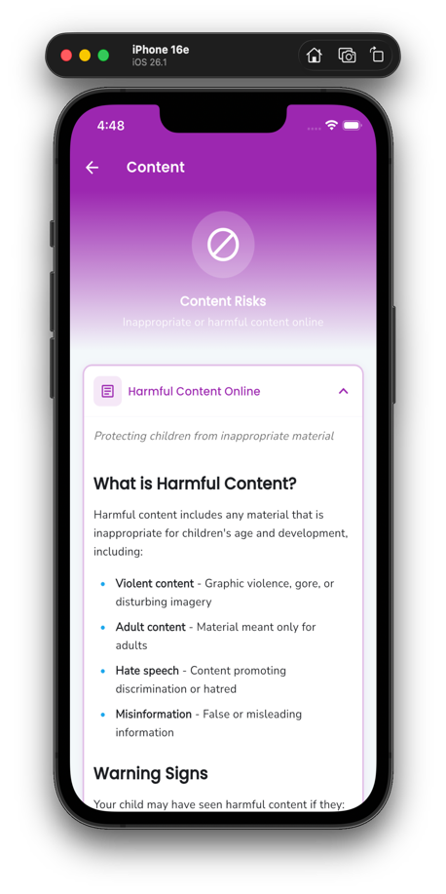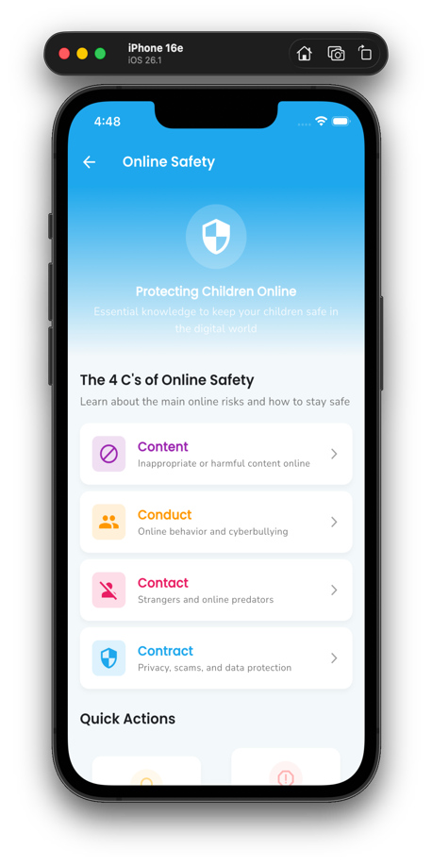

*Online Safety Hub with 4 C's Cards* *Detailed Content Risk Information*

## 5.5 Child-Friendly Mode

The child-friendly mode is designed from the ground up to be accessible, engaging, and safe for young users. Every element has been carefully considered to ensure children can navigate independently while remaining protected.

**Design Principles:**

* **Colorful Pastel UI:** Soft, welcoming colors create a non-threatening environment that children enjoy using. The palette has been tested with child focus groups.
* **Large Touch Targets:** All buttons and interactive elements are at least 60px in size, accommodating small fingers and reducing frustration from missed taps.
* **Minimal Text:** Navigation relies heavily on icons and images, making the app accessible to pre-readers and early readers.
* **Engaging Animations:** Subtle animations and visual feedback make interactions feel responsive and fun.
* **Safe Content Only:** Content is automatically filtered based on age, ensuring children never encounter inappropriate material.

**PIN Security System:**

Each child has their own 4-digit PIN that they can enter to access their personalized space. This provides several benefits:

* Children feel ownership of their account
* Siblings cannot access each other's content inappropriately
* Parents maintain oversight as PIN creators
* Teaches children basic digital security habits

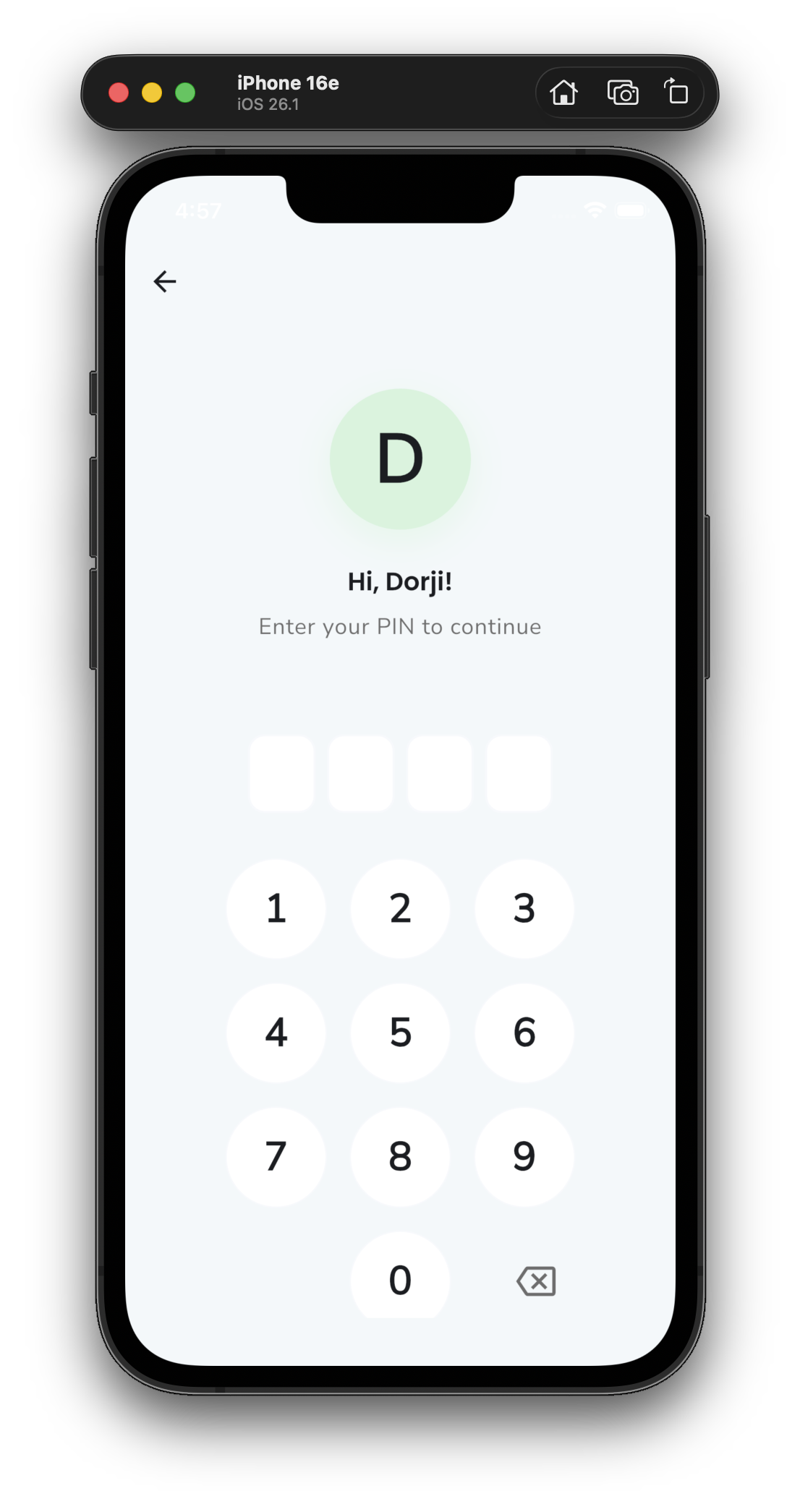

*Child PIN Login Screen*

## 5.6 Community Engagement

The community engagement features transform the app from an information resource into a platform for active participation in child protection activities. These features connect families with local support systems and enable direct reporting of concerns.

**Events Section:**

The events feature enables government agencies, NGOs, and partner organizations to publish upcoming activities directly to families:

* **Browse Events:** View all upcoming events in a card-based or list format with key details visible at a glance.
* **Filter by Category:** Filter events by type (seminars, workshops, training sessions, community gatherings) to find relevant activities.
* **Filter by Audience:** See events specifically for parents, children, educators, or community workers.
* **Event Details:** Full information including date, time, location, hosting agency, description, and registration links.
* **Agency Tags:** Events are tagged by hosting agency (UNICEF, NCWC, MOH, MOE, etc.) for easy identification.

**Incident Reporting:**

The reporting system provides a safe, confidential channel for users to report child protection concerns:

* **Easy-to-Use Form:** A guided form walks users through providing necessary information without overwhelming them.
* **Direct Channel:** Reports go directly to appropriate child protection agencies for action.
* **Anonymity Option:** Users can choose to submit reports anonymously if they prefer.
* **Tracking:** Non-anonymous reporters can track the status of their submitted concerns.

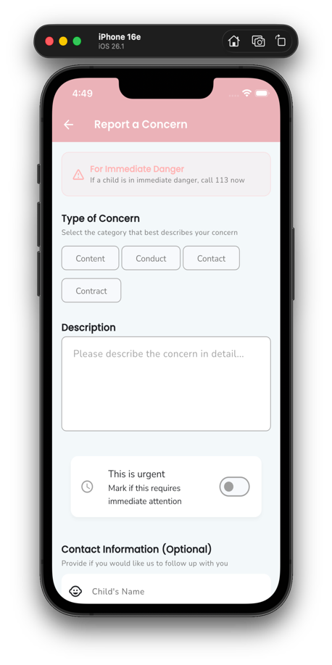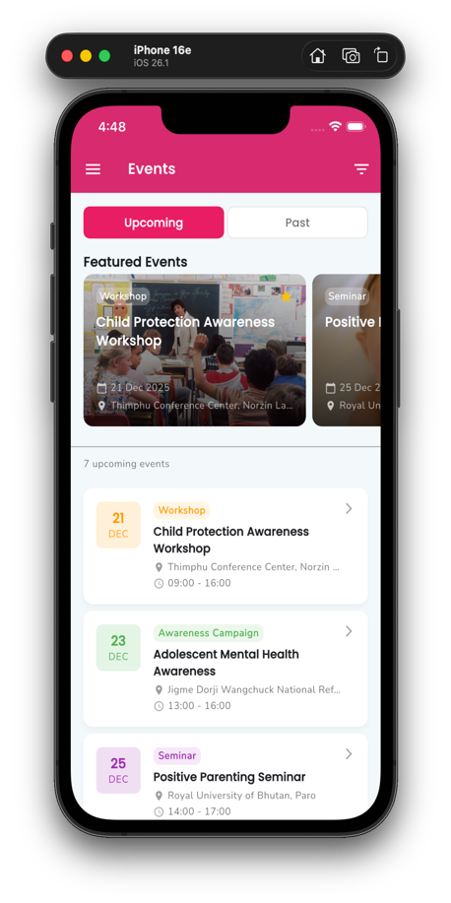

*Events List with Filtering Options* *Report a Concern Form*

## 5.7 Bilingual Support

**Languages:**

* **English** - Primary, fully implemented
* **Dzongkha** - National language, structure ready

**Impact:** Ensures rural and non-English speaking families can access all features.

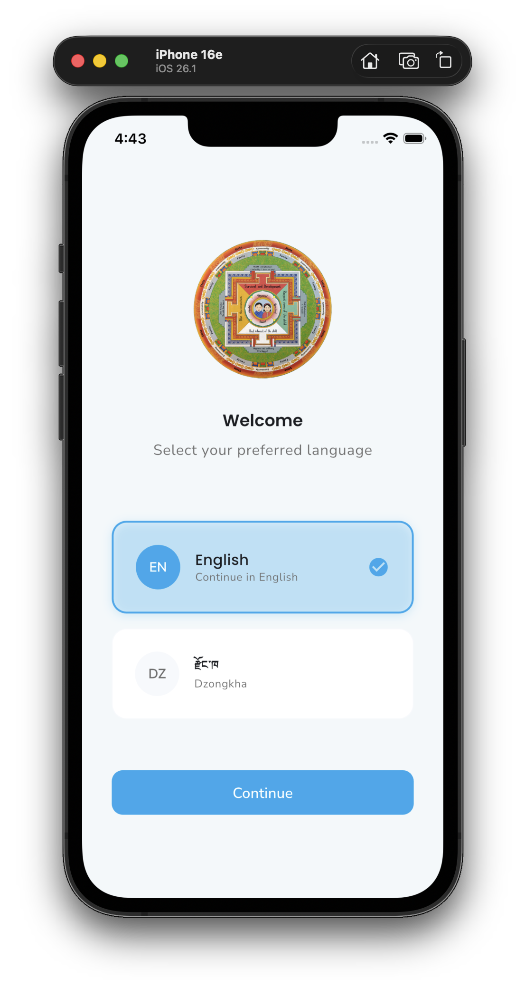

*Language Selection*

# 6. Backend Content Management System

## 6.1 System Architecture

Three-tier architecture for end-to-end content flow:

1. **Admin CMS (Web Portal)** - Content managers create and edit content
2. **Backend API (REST/JSON)** - RESTful services + database
3. **Mobile App (Flutter)** - Users see filtered content

## 6.2 Admin CMS Portal

**Who Uses It:**

* UNICEF content editors
* Partner agency staff (events)
* Translators (Dzongkha content)
* System administrators

**Key Capabilities:**

|  |  |
| --- | --- |
| **Feature** | **Description** |
| Content Editor | Rich markdown editor with preview |
| Media Library | Upload images, link YouTube videos |
| Multi-language | Side-by-side English/Dzongkha editing |
| Age Targeting | Select which age groups see content |
| Publish Workflow | Draft → Review → Publish |
| Version History | Track all changes with rollback |

## 6.3 Content Types

|  |  |  |
| --- | --- | --- |
| **Content Type** | **Admin Actions** | **App Display** |
| ICAP Chapters | Add/edit chapters, topics, videos | Learning section with filtering |
| Events | Create events, set dates, links | Events calendar with filters |
| Safety Content | Update 4 C's topics, tips | Online Safety hub |
| Chatbot | Add Q&A pairs, update intents | Chatbot conversations |

**Key Benefit:** Content updates reflect immediately in app - no app store approval needed.

## 6.4 API Integration

**Technical Stack:**

|  |  |
| --- | --- |
| **Component** | **Technology** |
| Mobile App | Flutter + Riverpod |
| API Client | HTTP |
| Backend API | REST/JSON |
| Database | MySQL/MongoDB |
| Videos | YouTube (no hosting cost) |

**App Features:**

* Automatic retry on network failure
* Local caching (24-hour)
* Offline reading capability

# 8. Commercial Proposal

This section outlines the cost breakdown for the development of the Child Mandala App. **Note:** The Interactive Mandala and News Portal were developed previously and are not included in this proposal.

|  |  |
| --- | --- |
| **TOTAL PROJECT COST** | **Nu. 1,500,000** |

**Notes:**

* All prices are in Bhutanese Ngultrum (Nu.)
* Interactive Mandala and News Portal are existing features - not charged
* AI Chatbot development includes prototype with future LLM integration capability
* Backend CMS includes admin portal, database setup, and API development
* Testing & QA covers both mobile app and backend systems
* Price includes 3 months post-launch support and bug fixes

**Let's protect Bhutan's children together.**

UNICEF Bhutan | 2025